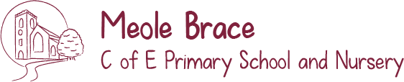
Let Your Light Shine!

Maths in Early Years

We plan whole class and small group maths activities which use both the indoor and outdoor environments to help children develop early maths skills and understanding of concepts.
In Early Years, we focus on developing children’s knowledge of number (number sense) and early reasoning.
Our planned activities are practical and encourage children to explore and talk about numbers to 10 and numerical patterns. Our maths follows the NCETM Mastering Number in Reception Programme.
We hold a Mastering Number Workshop for parents and carers to attend with games and activities you can do at home to help your child develop and practise their mathematical skills.

We aim to develop the following skills in Maths by the end of EYFS:
• I can count objects and understand that counting helps me find the number in a set.
• I can subitise (see and say) arrangements of up to five and start to subitise beyond five.
• I can talk about ‘parts’ and ‘wholes’ when exploring objects (e.g. cake) and sets of objects, and know that the parts of a number can help me remember number facts.
• I can compare objects and quantities and talk about them using the words: bigger/ smaller, heavier/ lighter, longer/ taller/shorter.
• I can compare sets of objects and numbers and use the language of more than/ fewer than, less and the same.
• I can solve practical problems including numbers of objects changing, e.g. children coming and going from the painting table, doubling, halving and sharing.
• I enjoy exploring and noticing patterns in shape and numbers.
• I can measure things in different ways using objects and equipment.
• I can explore everyday objects and use mathematical language to describe them.
• I am Key Stage One ready.

